DR Protection Groups with ORM stack

Contents

1. Introduction 2
2. Workflow diagram to deploy the stack 3
3. Create stack for DR Protection Groups 4
4. Plan the Job 6

Introduction

A DR Protection Group groups together all the components of a full stack application so that all the components can be recovered together to restore the full stack application.

Workflow diagram to deploy the stack

Below diagram shows how the Terraform Artifact are applied in the OCI. While creating a ORM stack, using terraform deliverables Init, Plan and Apply is the flow to provision the resource in the OCI. We can have the deliverables in any of below.

- GitLab/GitHub Repo
- Bitbucket
- Can be in folder/.zip in the local disk
- Object Storage Bucket
- Can be in compartment
- Oracle provided Template


Prerequisite
- Create a OCID of the member (Autonomous_Database, Compute_Instance, Database, Volume_Group)
- Create an object storage bucket

Create stack for DR Protection Groups

Go to OCI Console Developer Services Resource Manager Stacks select the compartment Create Stack

My Configuration Folder Browse Select the “DR Protection Groups” folder that contains the terraform Upload

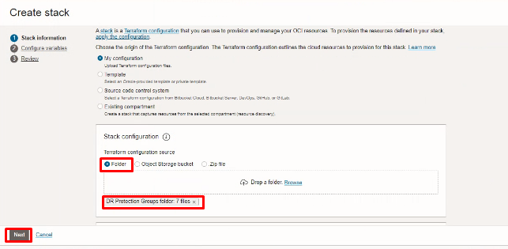

Select the parameters as per the below screen,
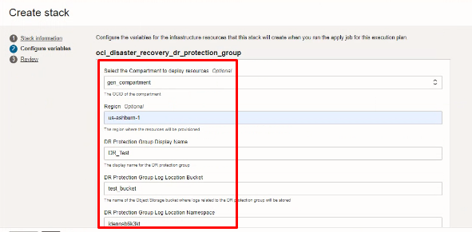
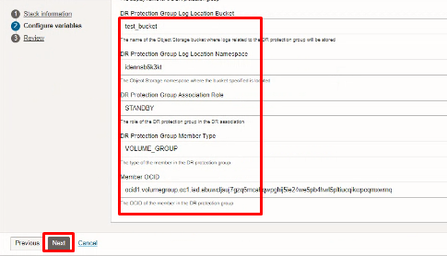
Click “NEXT”

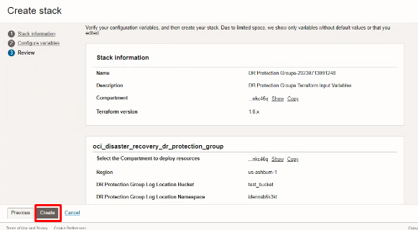

Click “CREATE”

Plan the Job

Click the “Plan”
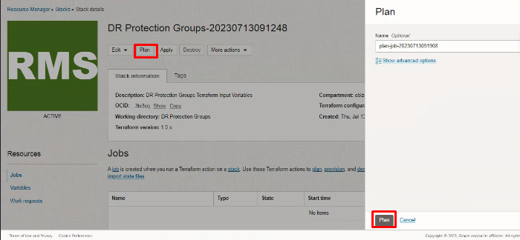

Verify the Plan is successful.

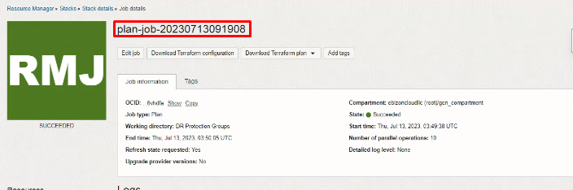

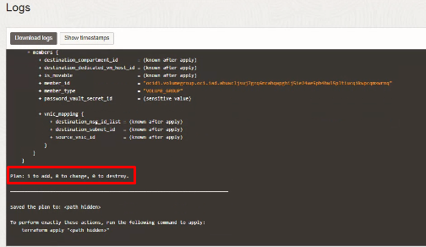

#END#

